MID SEATWORK 1

Question 1 — Design and Justify a Procedural Solution

I would implement the solution as an Oracle PL/SQL procedure because the main purpose is to perform an enrollment operation in the database. The procedure receives the student ID and classroom ID, checks the classroom capacity, and returns a status using an OUT parameter.
I chose a procedure instead of a function because the main task is to perform a database action, not simply calculate a value. The procedure returns 0 for successful enrollment and -1 when the classroom is full. It also provides database abstraction because the application does not need to handle the capacity-checking logic itself.

Oracle PL/SQL Procedure

CREATE OR REPLACE PROCEDURE register_student (
p_student_id IN NUMBER,
p_room_id IN NUMBER,
p_status OUT NUMBER
)
IS
v_current_students NUMBER;
v_room_capacity NUMBER;
room_full EXCEPTION;
BEGIN
SELECT COUNT(*)
INTO v_current_students
FROM enrollments
WHERE room_id = p_room_id;

SELECT capacity
INTO v_room_capacity
FROM classrooms
WHERE room_id = p_room_id;

IF v_current_students < v_room_capacity THEN
INSERT INTO enrollments (student_id, room_id)
VALUES (p_student_id, p_room_id);

p_status := 0;
ELSE
RAISE room_full;
END IF;

EXCEPTION
WHEN room_full THEN
p_status := -1;
END register_student;
/

Test Results
The procedure was tested with an available classroom and returned 0, meaning the student was successfully registered.
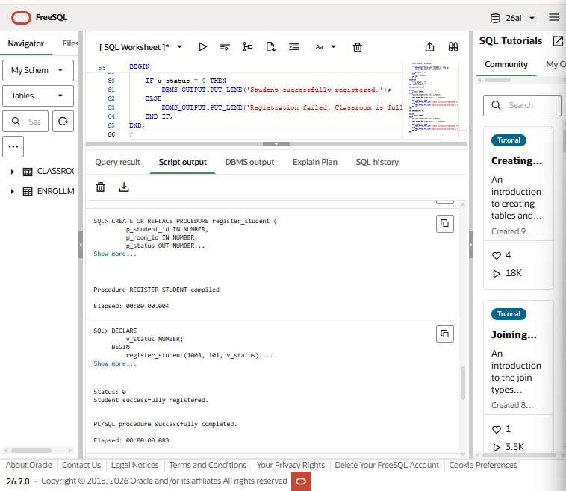
It was also tested with a full classroom and returned -1, meaning the enrollment was rejected.
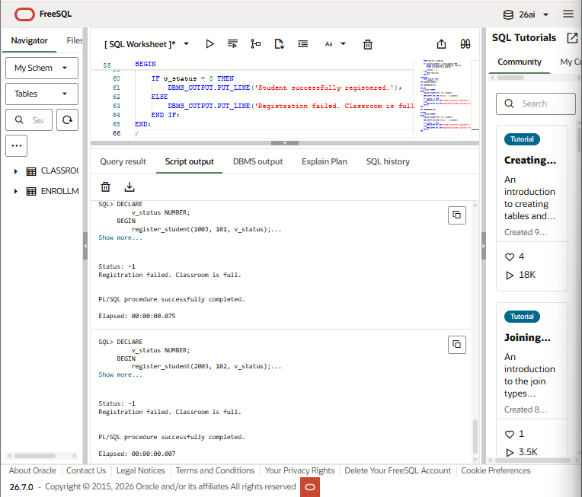

Exception and Data Integrity
I would use exit instead of continue when the classroom is full because the enrollment operation should stop when there is no available space. The room_full exception is raised and handled by setting the status to -1.
The solution protects data integrity by checking the classroom capacity before inserting the enrollment record. If the classroom is full, the INSERT does not happen, preventing the number of students from exceeding the room's capacity.

Question 2 — Evaluate External Language Routines vs. SQL-Native Code
A bank can use external languages such as C, C++, or Java, or use SQL-native procedural code for image comparison and geometric calculations.
Performance
External languages such as C and C++ can be fast for complex calculations. However, calling external routines can add overhead because data may need to move between the database and the external code. SQL-native code avoids much of this overhead when the database already provides the needed functions.
Security
External routines have greater security risks because they may access resources outside the normal SQL environment. Poorly written code could cause unauthorized data access or even corruption of database structures. SQL-native code generally operates within the database's existing security controls.
Maintainability
SQL-native code is generally easier to maintain because it stays inside the database environment. External routines require additional code, libraries, compilation, deployment, and runtime configuration.
Recommendation
For a bank, I would recommend SQL-native procedural code when it can perform the required operations effectively. It provides better control, easier maintenance, and fewer security risks. External routines should only be used when specialized operations cannot be performed efficiently using the database's native capabilities.
External routines should then be properly restricted and sandboxed because of risks involving unauthorized data access, database corruption, address-space execution, and sandboxing overhead. That’s all sir Jim!

